Third Grade

Homework Tasks

2018-2019

ASU Preparatory Academy

Name:____________________

Math
Homework Tasks

Understanding Addition
1. Solve each problem and then tell someone a number story to go with it.
Example: 27 +15 = 42 Sarah had 27 stickers and she bought 15 more at the store. Now Sarah has 42 stickers all together.
Solve:
33 + 54 = ____
65 + 19 = ____

2. Solve each problem and then tell someone a number story to go with it.
Example: 27 +15 = 42 Sarah had 27 stickers and she bought 15 more at the store. Now Sarah has 42 stickers all together
Solve:
75 + 14 = ____
67 + 18 = ____

3. Solve each problem and then tell someone a number story to go with it.
Example: 27 +15 = 42 Sarah had 27 stickers and she bought 15 more at the store. Now Sarah has 42 stickers all together.
Solve:
15 + 29 = ____
78 + 19 = ____

4. Solve each problem and then tell someone a number story to go with it.
Example: 27 +15 = 42 Sarah had 27 stickers and she bought 15 more at the store. Now Sarah has 42 stickers all together.
Solve:
35 + 64 = ____
67 + 38 = ____

5. Find the missing number.
Example: 23 + ___?___ = 86 Answer: 23+63=86
33 +____ = 100
41+ ____= 67
19 + ____ = 72

6. Find the missing number.
Example: 23 + ______ = 86 Answer: 23+63=86
56 +____ = 72
21+ ____= 46
79 + ____ = 98

7. Find the missing number.
Example: 23 + ______ = 86 Answer: 23+63=86
31 +____ = 68
29 + ____= 92
12 + ____ = 49

8. Find the missing number.
Example: 23 + ______ = 86 Answer: 23+63=86
32 +____ = 58
47+ ____= 73
19 + ____ = 67

9. Pick 2 two digit numbers. Draw a picture and write an addition number sentence. Try doing five problems.
Example: 11 + 31 = 42

x x x x x x x x x x x | o o o o o o o o o o o o o o o o o o o o o o o o o o o o o o o

10. Pick 2 two digit numbers. Draw a picture and write an addition number sentence. Try doing five problems.
Example: 11 + 31 = 42

x x x x x x x x x x x | o o o o o o o o o o o o o o o o o o o o o o o o o o o o o o o

11. Pick 2 two digit numbers. Draw a picture and write an addition number sentence. Try doing five problems.
Example: 11 + 31 = 42

x x x x x x x x x x x | o o o o o o o o o o o o o o o o o o o o o o o o o o o o o o o

12. Pick 2 two digit numbers. Draw a picture and write an addition number sentence. Try doing five problems.
Example: 11 + 31 = 42

x x x x x x x x x x x | o o o o o o o o o o o o o o o o o o o o o o o o o o o o o o o

13. Show 5 different ways to make 25 and 5 different ways to make 30.
Example: 24 + 1 = 25 29+1 = 30

14. Show 5 different ways to make 40 and 5 different ways to make 15.
Example: 39 + 1 = 40 14 + 1 = 15

15. Show 5 different ways to make 50 and 5 different ways to make 18.
Example: 49 + 1 = 50 17 + 1 = 18

16. Show 5 different ways to make 14 and 5 different ways to make 35.
Example: 13 + 1 = 14 34 + 1 = 35

17. Practice finding the whole when you add two parts. Do five problems.
Example: Using a part + a part = the whole
This example shows 32 + 51 = 83
Part  32 | Part  51
Whole
83

18. Practice finding the whole when you add two parts. Do five problems.
Example: Using a part + a part = the whole
This example shows 32 + 51 = 83
Part  32 | Part  51
Whole
83
19. Practice finding the whole when you add two parts. Do five problems.
Example: Using a part + a part = the whole
This example shows 32 + 51 = 83
Part  32 | Part  51
Whole
83
20. Practice finding the whole when you add two parts. Do five problems.
Example: Using a part + a part = the whole
This example shows 32 + 51 = 83
Part  32 | Part  51
Whole
83

21. Show 5 different ways to make 55 and 5 different ways to make 75.
Example: 54 + 1 = 55
74 + 1 = 75

22. Show 5 different ways to make 49 and 5 different ways to make 86.
Example: 48 + 1= 49
85 + 1 = 86

23. Show 4 different ways to make ten on a ten frame.
6+4=10
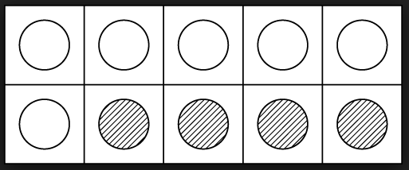

24. Show 5 different ways to make 100 and 5 different ways to make 500.
Example: 25 + 75= 100
250 + 250 = 500

25. Use the part, part, whole model, find the missing part. Try doing five problems.
Example:

Part  ? | Part  51
Whole
83

This model is written as ______ +51=83

26. Have your child complete these 5 missing number problems
___ + 9 = 27
___+ 45 = 84
___+ 96 = 127
___ + 115 = 163
___ + 143 = 189

27. Have your child complete these 5 missing number problems
___ + 19 = 82
___+ 25 = 56
___+ 76 = 132
___ + 145 = 192
___ + 103 = 167

28. Have your child complete these 5 missing number problems.
___ + 49 = 72
___+ 57 = 98
___+ 114 = 165
___ + 78 = 106
___ + 98 = 139

29. Have your child complete these 5 missing number problems.
___ + 58 = 87
___+ 65 = 93
___+ 109 = 123
___ + 135 = 147
___ + 133 = 169

30. Write a story problem using the numbers 5, 10, and 15. Draw a picture to show how you solved the problem.

31. Write a story problem using the numbers 22, 46, and 68. Draw a picture to show how you solved the problem.

32. Write a story problem using the numbers 15, 25, and 40. Draw a picture to show how you solved the problem.

33. Write a story problem using the numbers 4, 19, and 23. Draw a picture to show how you solved the problem.

34. Solve the word problem. Draw a picture if needed.

- The school has two 3rd grade classes. Each class has 22 students. There are 50 seats in the cafeteria. How many extra seats are there when they go to lunch?

- There are 12 kids on the swing, 34 playing tag and 26 playing hopscotch. How many kids are there in all?

35. Solve the word problem. Draw a picture if needed.
  - The school has two 3rd grade classes. One class has 25 students and the other class has 27 There are 75 seats in the cafeteria. How many extra seats are there when they go to lunch?
  - There are 13 kids on the swing, 28 playing tag and 19 playing hopscotch. How many kids are there in all?

36. Practice the addition facts using your flashcards.

37. Give a math addition time test using the one provided. Try to do all of the
problems in 2 minutes with no more than 2 mistakes.

Understanding Subtraction

38. Solve each problem and then tell someone a number story to go with it.
Example: 42-15 = 27
Sarah had 42 stickers and she gave away 15 to her friend Emily. Now Sarah has 27 stickers
left.
Solve:
- - 33 = ____
65 - 19 = ____

39. Solve each problem and then tell someone a number story to go with it.
Example: 42-15 = 27
Sarah had 42 stickers and she gave away 15 to her friend Emily. Now Sarah has 27 stickers
left.
Solve:
45 - 13= ____
84 - 17= ____

40. Solve each problem and then tell someone a number story to go with it.
Example: 42-15 = 27
Sarah had 42 stickers and she gave away 15 to her friend Emily. Now Sarah has 27 stickers
left.
Solve:
87 - 39= ____
66 - 45= ____

41. Solve each problem and then tell someone a number story to go with it.
Example: 42-15 = 27
Sarah had 42 stickers and she gave away 15 to her friend Emily. Now Sarah has 27 stickers
left.
Solve:
78 - 37 = ____
79 - 36 = ____

42. Find the missing number in each equation.
Example: 86 - ______ = 57
Answer: 86-29=57
Solve:
14 - ____ = 8
25 - ____ = 20
108 - ____ = 100

43. Find the missing number in each equation.
Example: 86 - ______ = 57
Answer: 86-29=57
Solve:
109 - ____ = 33
304 - ____ = 234
287 - ____ = 198

44 Find the missing number in each equation.
Example: 86 - ______ = 57
Answer: 86-29=57
Solve:
99 - ____ = 67
342 - ____ = 125
189 - ____ = 126

45. Find the missing number in each equation.
Example: 86 - ______ = 57
Answer: 86-29=57
Solve:
78 - ____ = 49
376 - ____ = 127
289 - ____ = 243

46. Pick 2, two digit numbers. Draw a picture and write a subtraction number sentence. Try doing five problems.
Example: 42 – 11 = 31

47. Subtract from 10 and 15. Do four problems for each number.
Example:
10 - ____ = ____
15 - ____= ____

48. Subtract from 25 and 40. Do four problems for each number.
Example:
25 - ____ = ____
40 - ____= ____

49. Subtract from 36 and 47. Do four problems for each number.
Example:
36 - ____ = ____
47 - ____= ____

50. Subtract from 50 and 58. Do four problems for each number.
Example:
50 - ____ = ____
58 - ____= ____

51. When you know the whole and a part, you can subtract to find the missing part. Try doing five problems.
Example:
This example shows 83 – 32 = 51
Part  32 | Part  ?
Whole
83

52. Subtract from 75 and 100. Do four problems for each number.
Example:
75 - ____ = ____
100 - ____= ___

53. Subtract from 150 and 250. Do four problems for each number.
Example:
150 - ____ = ____
250 - ____= ___

54. When you know the whole and a part, you can subtract to find the missing part. Try doing five problems.
Example:
This example shows 60 – 20 = 40
Part  20 | Part  ?
Whole
60

55. Have your child complete 5 missing number problems.
Example:
___ - 10 = 5
___- 5 = 25
___ - 40 = 90
___ - 115 = 139
___ - 143 = 92

56. Have your child complete 5 missing number problems.
Example:
___ - 17 = 68
___- 25 = 67
___ - 87 = 56
___ - 37 = 109
___ - 17 = 45

57. Have your child complete 5 missing number problems.
Example:
___ - 27 = 57
___- 45 = 19
___ - 96 = 46
___ - 115 = 139
___ - 143 = 92

58. Have your child complete 5 missing number problems.
Example:
___ - 36 = 56
___- 35 = 15
___ - 56 = 10
___ - 15 = 145
___ - 192 = 92

59. Write the fact family for five of the following sets of numbers:
11, 25, 36 25, 30, 55 30, 30, 60 11, 22, 33 40, 60, 100
45, 45, 90 35, 70, 105 110, 115, 125 125, 150, 275 200, 300, 500
Example: the fact family for 10, 20, 30
10 + 20 = 30 30 – 10 = 20
20 + 10 = 30 30 – 20 = 10

60. Write the fact family for five of the following sets of numbers:
10, 24, 34 23, 35, 58 20, 44, 64 18, 23, 41 30, 70, 100
46, 47, 93 25, 70, 95 100, 125, 135 135, 160, 295 204, 343, 547
Example: the fact family for 10, 20, 30
10 + 20 = 30 30 – 10 = 20
20 + 10 = 30 30 – 20 = 10

61. Solve the word problem. Draw a picture if needed.
a. There were 68 erasers in the box. Twelve were used. How many erasers are left?

b. There are 90 bikers that leave the school each day. 43 go right and the rest go left. How many bikers turn left?

62. Solve the word problem. Draw a picture if needed.
a. There were 95 erasers in the box. 12 were used. How many erasers are left?
b.There are 86 bikers that leave the school each day. 67 go right and the rest go left. How many bikers turn left?

63. Solve the word problem. Draw a picture if needed.
a.There were 56 erasers in the box. 14 were used. How many erasers are left?
b.There are 72 bikers that leave the school each day. 54 go right and the rest go left. How many bikers turn left?

64. Practice the subtraction facts using your flashcards.

65. Give a math subtraction timed test using the one provided. Try to do all of the problems in 2 minutes with no more than 2 mistakes.

Addition/Subtraction Strategies

66. Practice adding 3 numbers that equal a number up through 100. Do 4 more problems.
Example: 20 + 30 = 50 + _____.

67. Practice subtracting 3 numbers starting from 100.
Example: 100 – 45 = 55 55 – 20 = 35 35 – 15 = 20

68. Count by 10s. Which number comes next?
40, 50, 60, 70, ______
110, 120, 130, 140, ______
250, 260, 270, 280, ______
13, 23, 33, 43, ______
36, 46, 56, 66, ______

69. Count by 3s. Which number comes next?
43, 46, 49, 52, ______
116, 119, 122, 125, ______
259, 262, 265, 268, ______
10, 13, 16, 19, ______
36, 39, 42, 45, ______

70. Count by 4s. Which number comes next?
44, 58, 62, 66, ______
110, 114, 118, 122, ______
258, 262, 266, 270, ______
14, 18, 22, 26, ______
46, 50, 54, 58, ______

71. Count by 6s. Which number comes next?
46, 52, 58, 64, ______
112, 118, 124, 130, ______
224, 230, 236, 242, ______
16, 22, 28, 34, ______
36, 42, 48, 54, ______

72. Are the equations true or false?
32 + 23 = 40 + 15
42 + 56 = 54 + 32
15 + 35 = 25 + 25

73. Count by 100s. Which number comes next?
300, 400, 500, 600, _____
233, 333, 433, 533, _____
545, 645, 745, 845, ____
700, 800, 900, 1,000, _______
850, 950, 1050, 1150, ______

Exploring Quantities:

74. Write your numbers 50 to 120.

75. Write what two numbers come after each of these numbers:
23, 19, 34, 10, 41, 32, 56, 71, 11, 63, 98, 150, 143, 200, 439

76. Write what two numbers come before each of these numbers:
5, 98, 34, 13, 67, 45, 32, 89, 76, 90, 54, 67, 145, 231, 465

77. Skip count by 2’s to 120 (2, 4, 6, 8, 10, etc.) If this is easy, try writing the numbers.

78. Skip count by 5’s to 120 (5, 10, 15, 20, etc.) If this is easy, try writing the numbers.

79. Skip count by 10’s to 120 (10, 20, 30, 40, etc.) If this is easy, try writing the numbers.

80. Skip count by 3’s to 36 (3, 6, 9, 12, etc.) If this is easy, try writing the numbers.

81. Skip count by 4’s to 48 (4, 8, 12, 16, etc.) If this is easy, try writing the numbers.

82. Skip count by 6’s to 72 (6, 12, 18, 24, etc.) If this is easy, try writing the numbers.

83. Skip count by 7’s to 84 (7, 14, 21, 28, etc.) If this is easy, try writing the numbers.

84. Skip count by 8’s to 96 (8, 16, 24, 32, etc.) If this is easy, try writing the numbers.

85. Skip count by 9’s to 108 (9, 18, 27, 36, etc.) If this is easy, try writing the numbers.

86. Skip count by 11’s to 132 (11, 22, 33, 44, etc.) If this is easy, try writing the numbers.

87. Skip count by 12’s to 144 (12, 24, 36, 48, etc.) If this is easy, try writing the numbers.

88. Write these numbers: 7, 12, 16, 9, 3, 8, 1, 23, 50, 64, 71, 86, 90, 93 Now circle the even numbers.

89. Write these numbers: 1, 6, 12, 11, 21, 42, 33, 56, 76, 43, 54, 91, 81 Now circle the odd numbers.

Use Place Value to Read, Write, Represent and Compare Numbers:

90. Write these numbers in order from least to greatest: 32, 11, 44, 32, 98, 56, 78, 34, 67, 90, 54, 61, 70, 54, 31, 14, 22, 70, 41.

91. Write these numbers in order from greatest to least: 3, 76, 34, 90, 76, 23, 45, 21, 37, 89, 7, 54, 67, 9, 87, 34, 21, 54, 67, 65

92. Choose a number and identify which digit (number) is in the ones place, tens place and/or hundreds place. Please do 5 numbers.
Example: 38 – 38 means - 3 tens and 8 ones or it can mean 8 ones and 3 tens.

215 – 215 means: 2 hundreds, 1 ten and 5 ones or 5 ones, 1 ten and 2 hundreds.
  - 29
  - 196
  - 37
  - 65

93. Choose a number and identify which digit (number) is in the ones place, tens place and/or hundreds place. Please do 5 numbers.
Example: 38 – 38 means: 3 tens and 8 ones or it can mean 8 ones and 3 tens.

215 – 215 means: 2 hundreds, 1 ten and 5 ones or 5 ones, 1 ten and 2 hundreds.
  - 234
  - 325
  - 19
  - 56

94. Choose a number and identify which digit (number) is in the ones place, tens place and/or hundreds place. Please do 5 numbers.
Example: 38 – 38 means: 3 tens and 8 ones or it can mean 8 ones and 3 tens.

215 – 215 means: 2 hundreds, 1 ten and 5 ones or 5 ones, 1 ten and 2 hundreds.
  - 458
  - 290
  - 30
  - 59

95. Write a list of 2 two-digit numbers (10 through 99) with a space between them. Put in the greater than >, less than <, or equal = sign between them.
Example: 26 > 19, 59 < 73, 11 = 11

96. Compare these sets of numbers by writing >, < or =
234 ___ 321, 545___545, 674___565, 458___654, 556___132
Pick 6 of your own 3 digit numbers and compare them.

97. Write these numbers in Expanded Form
234 513 678 765 454 349 980 657 897 667 234 546 231
Example: 347 = 300 + 40 + 7

98. Write these numbers in Expanded Form
234 321 674 545 454 943 890 567 789 676 432 654 123
Example: 347 = 300 + 40 + 7

99. Write these numbers in Expanded Form
324 135 786 575 675 934 809 675 849 766 213 905 134
Example: 347 = 300 + 40 + 7

100. Write these numbers in Expanded Form
423 531 686 760 453 549 280 653 856 753 276 956 642
Example: 347 = 300 + 40 + 7

101. What is the value of the bold number. Write down the value
534 453 234 678 767 443 123 342 789 898 767 556 224

102. Write the number below in numerals.
Four hundred thirty-three
seven hundred thirty-four
eight hundred fifty-two
one hundred twenty
Example: two hundred eighty-nine-289

103. Round the following numbers to the 10’s place:
37, 42, 54, 33, 78, 90, 67, 87, 54, 70, 10, 21, 43, 66, 53, 45, 67, 87, 98
Example : 41 ~ 40 57 ~ 60

104. Round the following numbers to the 100’s place:
121, 342, 234, 554, 667, 878, 91, 345, 879, 432, 453, 566, 768, 613
Example: 324 ~ 300 478 ~ 500

105. Compare these sets of numbers by writing >, < or =
24 ___ 31, 55___45, 64___55, 48___64, 56___12
Pick 6 of your own 2 digit numbers and compare them.

106. Write these numbers in Expanded Form
34 13 78 75 54 49 80 67 97 67 34 46 31
Example: 47 = 40 + 7

Multiplication Strategies:

107. Solve each problem and then tell someone a number story to go with it.
Example: 3 x 5 = 15 Sarah had 3 sheets of stickers. Each sheet has 5 stickers. How many stickers does Sarah have in all? Sarah has 15 stickers in all.
Solve:
2 x 8= ____ 4 x 4=____ 5 x 7=____ 12 x 4=____
3 x 4= ____ 6 x 3=____ 8 x 3=____ 7 x 7=____

108. Solve each problem and then tell someone a number story to go with it.
Example: 3 x 5 = 15 Sarah had 3 sheets of stickers. Each sheet has 5 stickers. How many stickers does Sarah have in all? Sarah has 15 stickers in all.
Solve:
4 x 8= ____ 4 x 2=____ 5 x 3=____ 7 x 4=____
6 x 4= ____ 6 x 2=____ 2 x 3=____ 6 x 7=____

109. Solve each problem and then tell someone a number story to go with it.
Example: 3 x 5 = 15 Sarah had 3 sheets of stickers. Each sheet has 5 stickers. How many stickers does Sarah have in all? Sarah has 15 stickers in all.
Solve:
5 x 5= ____ 4 x 4=____ 3 x 3=____ 4 x 4=____
6 x 6= ____ 2 x 2=____ 2 x 8=____ 9 x 7=____

110. Solve each problem and then tell someone a number story to go with it.
Example: 3 x 5 = 15 Sarah had 3 sheets of stickers. Each sheet has 5 stickers. How many stickers does Sarah have in all? Sarah has 15 stickers in all.
Solve:
5 x 4= ____ 8 x 4=____ 9 x 3=____ 1 x 4=____
8 x 6= ____ 5 x 2=____ 8 x 8=____ 9 x 9=____

111. Find the missing number.
Example: 3 x ______ = 24 ANSWER: 3 x 8 =24

4x____ = 28
7x ____= 49
3x ____ = 21
5x_____=45
9x_____=36
11x____=99

112. Find the missing number..
Example: 3 x ______ = 24 ANSWER: 3 x 8 =24

7 x____ = 28
7 x ____= 35
3 x ____ = 24
5 x_____= 25
6 x_____=36
11 x____=22

113. Find the missing number.
Example: 3 x ______ = 24 ANSWER: 3 x 8 =24

2 x____ = 18
3 x ____= 15
2 x ____ = 24
6 x_____= 42
7 x_____= 21
5 x_____= 10

114. Draw an array for the following multiplication expressions.
4x3 7x4 2x5 8x6 1x7 3x9

115. Draw an array for the following multiplication expressions.
4x2 3x4 6x6 2x6 3x7 2x9

116. Draw an array for the following multiplication expressions.
3x3 4x4 5x5 3x6 1x3 4x9

117. Draw an array for the following multiplication expressions.
3x2 4x5 5x3 4x6 6x3 1x9

118. Draw a picture and write a multiplication number sentence. Try doing five problems.
Example: 6x3=18
119. Show 4 different ways to make 15 and 4 different ways to make 30.
Example:
6
3x2=6
2x3=6
6x1=6
1x6=6
120. Show 4 different ways to make 20 and 4 different ways to make 36.
Example:
6
3x2=6
2x3=6
6x1=6
1x6=6

121. Show 4 different ways to make 21 and 4 different ways to make 20.
Example:
6
3x2=6
2x3=6
6x1=6
1x6=6

122. Write an expression for the array shown below.

123. Write an expression for the array shown below.

124. Show 4 different ways to make 35 and 4 different ways to make 40.
Example:
6
3x2=6
2x3=6
6x1=6
1x6=6

125. Use the part, part, whole model, find the missing part. Try doing five problems.
Example:
Part  ? | Part  6
Whole
24

This model is written as ______ x 6= 24

126. Have your child complete 5 missing number problems.
Example:
___ x 3 = 27
___x 9 = 81
___x 7 = 49
___ x 6=30
___ x 3=18

127. Have your child complete 5 missing number problems.
Example:
___ x 9 = 18
___x 2 = 12
___x 7 = 35
___ x 6=42
___ x 5=15

128. Have your child complete 5 missing number problems.
Example:
___ x 4= 24
___x 4 = 12
___x 7 = 28
___ x 6= 36
___ x 5= 25

129. Have your child complete 5 missing number problems.
Example:
___ x 3= 24
___x 2 = 6
___x 4 = 36
___ x 6= 18
___ x 5= 45

130. Write an expression for the array shown below.

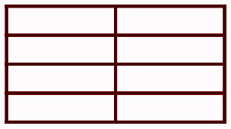

131. Write a multiplication story problem using the numbers 9, 5, and 45. Draw a picture to show how you solved the problem.

132. Solve the word problem. Draw a picture if needed.
a. )Judy filled water bottles to take to the beach. If each bottle contained 20
ounces, and she drank one bottle of water, how many ounces of water did.
she drink? Write a multiplication equation and solve

b.) Jill’s soccer team scored a total of 0 points per game for 5
games. How many total points did they score in all? Write a
multiplication equation and solve.

133. Solve the word problem. Draw a picture if needed.

- Judy filled water bottles to take to the beach. If each bottle contained 8 ounces, and she drank 3 bottles of water, how many ounces of water did she drink? Write a multiplication equation and solve.

- Jill’s soccer team scored a total of 4 points per game for 7 games. How many total points did they score in all? Write a multiplication equation and solve.

134. Solve the word problem. Draw a picture if needed.

- Judy filled water bottles to take to the beach. If each bottle contained 6 ounces, and she drank 5 bottles of water, how many ounces of water did she drink? Write a multiplication equation and solve.

- Jill’s soccer team scored a total of 3 points per game for 6 games. How many total points did they score in all? Write a multiplication equation and solve.

135. What multiplication property is shown by this equation? Try 3 more on your own..
1x4=4
The Zero Property
The Identity Property
The Commutative Property

136. What multiplication property is shown by this equation? Try 3 more on your own.
3x0=0
The Zero Property
The Identity Property
The Commutative Property

137. What multiplication property is shown by this equation? Try 3 more on your own.
7x6=6x7
The Zero Property
The Identity Property
The Commutative Property

138.
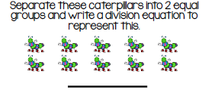

139. Practice the multiplication facts using your flashcards.

140. Give a math multiplication timed test using the one provided. Try to do all of the problems in 2 minutes with no more than 2 mistakes.

Division Strategies:

141. Solve each problem and then tell someone a number story to go with it.

Example: 15÷ 5 = 3 Sarah had 15 stickers. Each sheet has 5 stickers. How many sheets does Sarah have? Sarah has 3 sheets of stickers.
Solve:
16÷8= ____ 16÷4=____ 35÷7=____ 48÷4=____
12÷4= ____ 18÷3=____ 24÷3=____ 49÷7=____

142. Solve each problem and then tell someone a number story to go with it.

Example: 15÷ 5 = 3 Sarah had 15 stickers. Each sheet has 5 stickers. How many sheets does Sarah have? Sarah has 3 sheets of stickers.
Solve:
8÷4= ____ 15÷3=____ 30÷6=____ 48÷6=____
12÷2= ____ 18÷2=____ 24÷4=____ 56÷7=____

143. Solve each problem and then tell someone a number story to go with it.
Example: 15÷ 5 = 3 Sarah had 15 stickers. Each sheet has 5 stickers. How many sheets does Sarah have? Sarah has 3 sheets of stickers.
Solve:
6÷3= ____ 27÷3=____ 54÷6=____ 36÷6=____
14÷2= ____ 4÷2=____ 32÷4=____ 21÷7=____

144. Find the missing number.
Example: 24÷______ = 6 Answer: 24÷ 4 = 6
28÷____ = 4
49÷ ____= 7
21÷____ = 3
45÷_____=5
36÷_____=9

145. Find the missing number.
Example: 24÷______ = 6 Answer: 24÷ 4 = 6

36÷____ = 4
21÷ ____= 7
18÷____ = 3
25÷_____=5
27÷_____=9

146. Draw a picture and write a division number sentence. Try doing five problems.
Example : 18÷3=18

147. Show 4 different ways to divide from 45 and 4 different ways to divide from 30.
Example: 6
6÷2=3
6÷3=2
6÷1=6
6÷6=1

148. Show 4 different ways to divide from 16 and 4 different ways to divide from 20.
Example: 6
6÷2=3
6÷3=2
6÷1=6
6÷6=1

149. Practice finding the missing factor. Do five problems.
Example: Using a whole ÷ a part = a part
This example shows 21÷3 = 7

Part  3 | Part  7
Whole
21

150. Show 4 different ways to divide from 21 and 4 different ways to divide from 24.
Example:
6
6÷2=3
6÷3=2
6÷1=6
6÷6=1

151. Show 4 different ways to divide from 35 and 4 different ways to divide from 40.
Example:
6
6÷2=3
6÷3=2
6÷1=6
6÷6=1

152. Use the part, part, whole model to find the missing part. Try doing five problems.
Example:
Part  ? | Part  6
Whole
24
This model is written as 24÷6=_____

153. Have your child complete 5 missing number problems.

Example:
27÷3 =____
81÷9 = ____
49÷7 = _____
30÷6=____
18 ÷3=____

154. Write a division story problem using the numbers 14, 7, and 2. Draw a picture to show how you solved the problem.

155. Solve the word problem. Draw a picture if needed.

  - There are 20 children and 2 playgrounds. Each playground has an equal number of students. How many students are on each playground?

  - Alex has a total of 30 marbles. He wants to divide them equally in five bags. How many marbles will she put into each bag?

156. Solve the word problem. Draw a picture if needed.

  - There are 15 children and 3 playgrounds. Each playground has an equal number of students. How many students are on each playground?
  - Alex has a total of 24 marbles. He wants to divide them equally in 6 bags. How many marbles will she put into each bag?

157. Write an expression for the array shown below
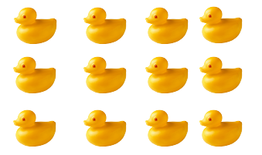

158. Practice the division facts using your flashcards

159. Give a math division time test using the one provided. Try to do all of the problems in 2 minutes with no more than 2 mistakes.

Understanding Fractions:

160. Name the shaded parts.
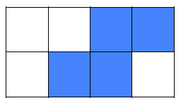

161. Draw three figures for 3/6 and 4/8 that are the same size and shape. What do you notice about all three figures?

162. Use the number lines below to identify the equivalent fractions.

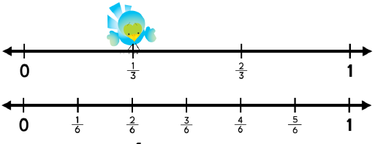

163. Write the equivalent fraction?
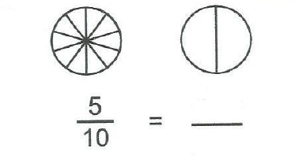

164. Write the Fractional Unit
Name the shaded part of the shape.
Name the unshaded part of the shape.

165. Use the number lines below to identify the equivalent fractions.
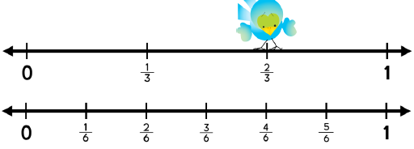

166. Name X on the number line below.

167. Write the Fractional Unit
Name the shaded part of the shape.
Name the unshaded part of the shape.
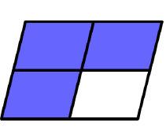

168. What fraction would go where X is on the number line below?
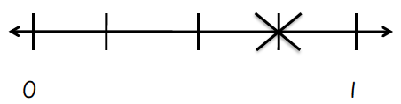

169. Hannah used 1 1/3 cups of sugar and 2 1/3 cups of flour for her dessert. How many cups did she use altogether?

170. Use the number lines below to identify the equivalent fractions.
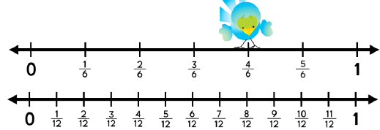

171. Write the equivalent fraction.
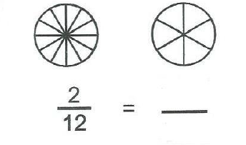

172. Name each fractional unit.
Name the shaded part of the shape.
Name the unshaded part of the shape.

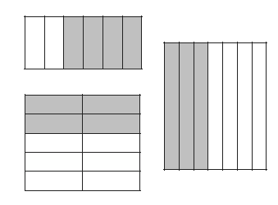

173. Which fraction is greater?
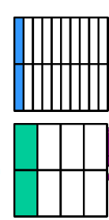

174. Meghan and Brooke had a pizza party. They had 4/8 pepperoni pizza left. They also had 5/8 plain pizza left. How much pizza in all do they have left?

175. Which fraction is greater?
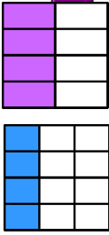

176. Allison’s mom told her she can watch TV for 4 hours during the weekend. She has watched 2 1/2 so far. How much time does she have left to watch TV?

177. Use the number lines below to identify the equivalent fractions.
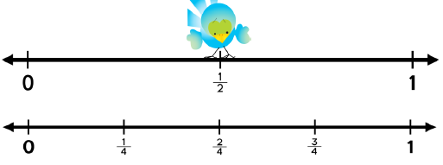

178. Write the equivalent fraction?
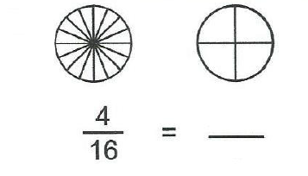

179. Name each fractional unit.
Name the shaded part of the shape.
Name the unshaded part of the shape.

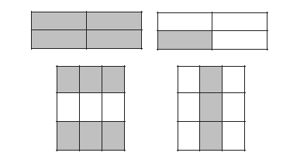

180. Daniel went to the gym and ran 1 4/5 miles on the treadmill. He then
used the bicycle and went 2 3/5 miles. How far did he work out altogether?

181. Write the equivalent fraction?
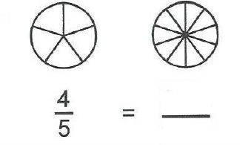

182. Practice fraction names using your flashcards.

183. Give a fraction time test using the one provided. Try to do all of the problems in 2 minutes with no more than 2 mistakes.

Measurement and Data:
184. It takes La’Kya 35 minutes to walk to the library.
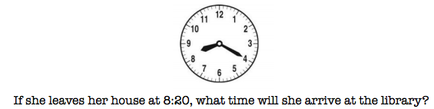

185. Use the graph below to answer the question.
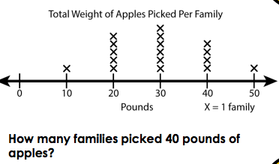

186. Find the unknown side length.

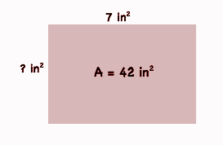

187. Use the graph below to answer the question.
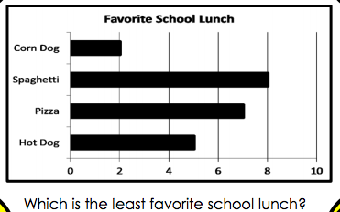

188. What is the area of the rectangle?
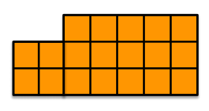

189. What is the area of each rectangle?

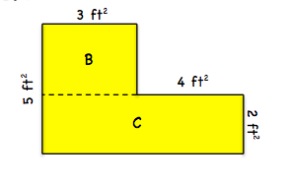

190. Find the unknown side length.
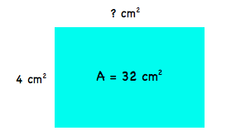

191. Use the graph below to answer the question.

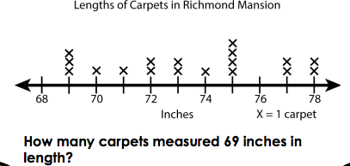

192. What is the area of the rectangle?
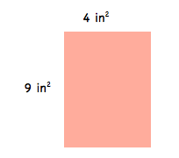

193. Use the graph below to answer the question.
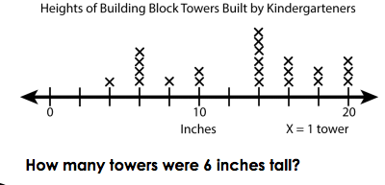

194. What is the area of each rectangle?
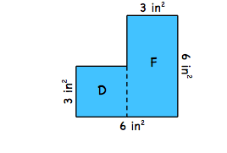

195. Use this data to draw a bar graph with an appropriate scale.

Students Number of Books
Jessie 15
Ross 30
Kelly 25
Bill 40

196. Show 3 possible rectangles that have the area of 12 square units.

197. Use the graph below to answer the question.
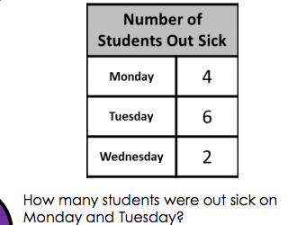

198. Use the graph below to answer the question.

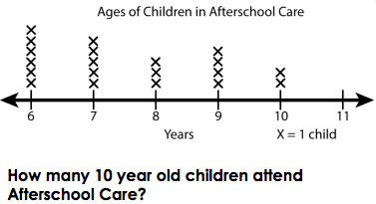

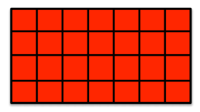
199. What is the area of the rectangle?

200. Use the graph below to answer the question.
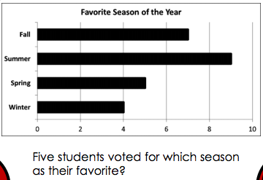

201. What is the area of the rectangle?
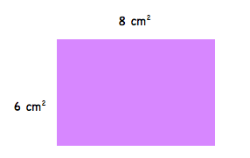

202. When school begins in the morning, the clock looks like this:
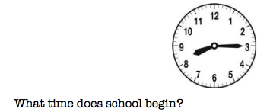

203. Use the graph below to answer the question.
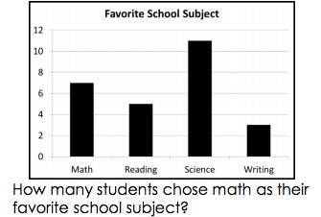

204. Find the unknown side length.
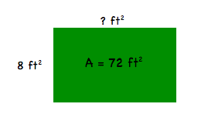

205. What time is shown on the watch below?
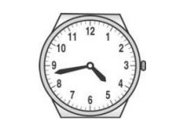

206. What is the area of the rectangle?
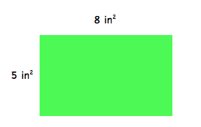

207. Use the graph below to answer the question.
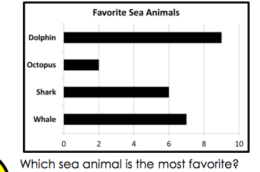

208. Jason’s clock looked like the following clock when he went to bed.
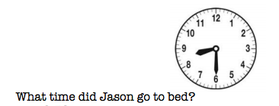

209. Use the graph below to answer the question.
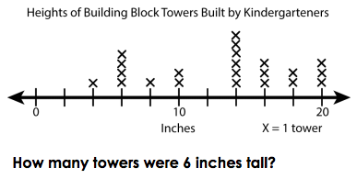

Geometry:

210. Which shapes are quadrilaterals?
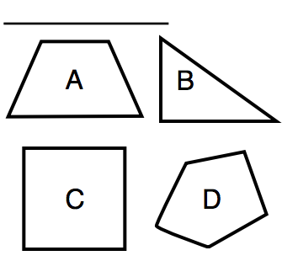

211. Mahkiya drew a quadrilateral. Her sides are not all equal in length. Which shape did she draw?

212. Which shapes are quadrilaterals, but not rectangles?
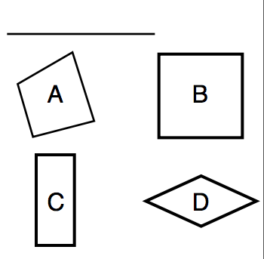

213. What is a polygon with 5 sides?

214. Which sides in the quadrilateral are parallel?
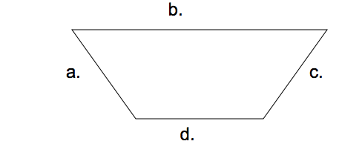

215. What is a polygon with 9 sides?

216. Which shapes are quadrilaterals, but not parallelograms?
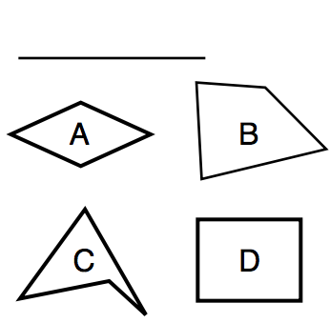

217. Which shapes are parallelograms?

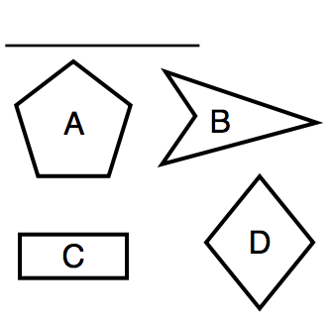

218. What is a polygon with 4 sides?

219. Brady drew a quadrilateral that has 4 equal sides and 4 equal angles. Which
quadrilateral did he draw?

220. What is a polygon with 3 sides?

221. What is a polygon with 6 sides?

222. Which quadrilateral is shown below?

223. What is a polygon with 7 sides?

Language Arts
Homework Tasks

224. Say the long vowel sounds that each letter makes. Remember, the vowels
are a, e, i, o, and u. Write one word using each vowel.

225. Say the short vowel sounds that each letter makes. Remember, the vowels
are a, e, i, o, and u. Write one word using each vowel.

226. Write three words that rhyme with each of the following words:
wig bat set bug log will can fun man

227. Write three words that begin with each of the following sounds:
ch sh wh th

228. Write three words that end with each of the following sounds
ch th sh tch ng

229. See how many words you can make with the following letters by putting a
different vowel in the blanks (vowels are a, e, i, o, and u)
b_____g d_______g b______t s_______t f_______t

230. Add the ending –ed, ing- and –s to the following words and write each word
you make in a sentence.
work, help, walk, color, brush

231. Add –er and –est to the following words and write each word in a sentence.
hard, loud, soft, kind, big

232. Add the prefix un – to the following words and write the new words. Have
your child explain the meaning of the new words.
Example: unhealthy means not healthy
healthy happy tie real able

233. Add the prefix re – to the following words and write the new words. Have
your child explain the meaning of the new words.
Example: replay means to play again
Do read fill use

234. Say the names of the food you ate for dinner. How many syllables does
each word have?

235. Write your full name, address and telephone number. Don’t forget to put
the comma between city and the state.

236. Write today’s date and your birthday two ways. Don’t forget to put
the comma between the date and year.
Example: September 1, 2006 and 9/1/06
How many months until your birthday?

237. Write three sentences that tell something. Don’t forget capitals and
periods.

238. Write three sentences that ask something. Don’t forget capitals and
periods.

239. Draw a summer picture. Write five sentences describing your picture.

240. Draw a winter picture. Write five sentences describing your picture.

241. Draw a spring picture. Write five sentences describing your picture.

242. Draw a fall picture. Write five sentences describing your picture.

243. Write 10 words that describe people (adjectives).

244. Write 3 sentences using adjectives (words that describe.) Underline the
adjectives.
Examples: the green grass grows.

245. Write 5 words that show action. (verb)

246. Write 3 sentences using contractions (do not = don’t). Punctuate and
capitalize your sentence.
were not, he is, I am, here is, could not, can not,
she is, we will, I have, is not

247. Write or draw 3 steps in order to tell how to do something.

248. Write five sentences about what you did in school today.

249. What is your favorite holiday? Draw a picture and write five sentences
telling what you do on that holiday.

250. Write a list of 5 good things you have done. Make sure you use capital
letters, correct spacing, and punctuation marks.

251. Write the names of the members of your family. Don’t forget to start each
name with a capital letter.

252. Write 5 sentences about your about your family and read it to them.

253. Write a recipe for making a sandwich.

254. Write and complete the following sentences and illustrate them on a
separate sheet of paper.
I can see_________. I can hear________. My best friend is ____________. I like ___________ and _____________, but I don’t like ______________. I like to go to __________________. I like to play____________. The food I like best is ______________________.

255. Write a thank you note to someone.

256. Write your spelling words in ABC (alphabetical) order.

257. Write 8 sentences using a spelling word in each sentence.

258. Spelling Rainbows – Write each of your spelling words with a pencil and
then trace it three times with three different colors.

259. Write a story using 5 of your spelling words. Don’t forget capital letters and
punctuation marks.

260. Write each of your spelling words. Now circle each of the vowels.

261. Write each of your spelling words. Now go back and circle all of the
consonants.

262. Have someone give you a written spelling test with this week’s words.
Practice the words you missed on the spelling test. Review all the words
one more time.

263. Read a book, write and illustrate what happened at the beginning, the
middle and the end of the story.

264. Write the synonym (words that mean almost the same thing) for each
word:
happy, mad, cold, big, kind, ocean

265. Write antonyms (words with opposite meanings) for the following words: boy, little, hot, fast, dark

266. Finish this sentence:
My favorite book is _____because_____ Tell your family about this
book.

267. Read these words: Tell their antonyms. (opposites).
hot, big, tall, sad, light, wet, & in

268. Read a book of your choice to an adult. After reading the book identify the
main character, setting and what happened in the beginning, middle and end of the book.

269. Find “something” of which you can read the most of. A Book, a magazine, a
newspaper, a cereal box, a comic book, and read it to someone.
Science/Social Studies
Homework Activities

270. Find one picture of each in a book, magazine, or newspaper: baby, child,
and adult. Tell how people change as they grow up.

271. Explain to your mom and/or dad three things you want and three things
you need. What is the difference between a want and a need?

272. Explain to your mom and/or dad what you should do if you are approached
by a stranger.

273. Look at a magazine picture. Now cover it and name the objects that you can
remember.

274. Get a map and locate Arizona. Using this map find: Mesa, Gilbert, Payson,
Phoenix, Tucson, Flagstaff, Yuma, the Grand Canyon and Four Corners.

275. Name 3 things made from plastic. Name 3 things made from wood.

276. Find 5 signs of fall. List them with an adult’s help and draw a picture.

277. Find 5 signs of winter. List them with an adult’s help and draw a picture.

278. Find 5 signs of spring. List them with an adult’s help and draw a picture.

279. Find 5 signs of summer. List them with an adult’s help and draw a picture.

280. Draw a picture of the frog life cycle and label each cycle: adult frog, eggs,
froglet, tadpoles.

281. Identify a helper in the community and describe how they help.

282. Identify the President of the United States and the Governor of Arizona
Discuss their responsibilities with your parents.

283. Pick 5 important events in your life and place them in order on a timeline.
284. Study photos of when you were younger. Write a description of how you
looked and how you have changed.

285. Write five facts about Martin Luther King Jr.

286. Write five facts about Abraham Lincoln.

287. Write five facts about George Washington.

288. Write five facts about Cesar Chavez..

289. List 3 differences between living in the desert and living where it snows a
lot.

290. List 5 different plants and 5 animals that live in the desert.

291. Identify and draw a plant and an animal that lives in the forest.

292. Identify and draw a plant and an animal that lives in the water.

293. Talk to your parents about the responsibilities of voting.

Student Choice Book Projects:
Homework Tasks
294.
295.
296.
297.

